Computational Fluid Dynamics Simulation of Full-size Upstream Flare Experiments

Anan Wang 1*, Isaac Sadovnik 1, Chong Tao 1, Jon Chow 1, Lei Sui 1, Gerard Bottino 1

Raj Venuturumilli 2, Peter Evans 2, David Newman 2, Jon Lowe 2, Johan Liekens 2

1Baker Hughes, 1100 Technology Park Dr, Billerica, MA 01821, United States

2bp, Sunbury on Thames, London, TW16 7LN, United Kingdom,

**\*** Correspondence: anan.wang@bakerhughes.com

**Abstract:** Understanding the influence of the operating conditions and the environmental factors on combustion efficiency and destruction and removal efficiency (CE/DRE) of flares is essential if their role in methane emissions, a potent but short-lived greenhouse gas, is to be better understood and mitigated. However, for un-assisted flares such as those commonly encountered in upstream oil and gas production, information remains scarce because of the complexity of conducting full-scale tests. Here, a three-stage protocol for the traceable use of computational fluid dynamics (CFD) as a tool for investigating flare combustion is presented to augment physical testing. The CFD model is first validated against an established reference flame dataset (Sandia Flame D) before comparison to full scale flare tests that use extractive sampling of the combustion plume. The results emphasize the critical role of vent gas net heating value (NHV) on flare combustion and crosswinds in reducing the combustion efficiency. The comparison helps pave the way for further use of CFD to validate flare designs and modes of operation and supports the use of parametric models to track and report methane losses from flaring.

**Keywords:** Flare, Combustion efficiency, CFD Flare combustion simulation

**1. Introduction**

A flare is a combustion device to burn off excess or unwanted gases in a safe and controlled way. Flares are found across the oil and gas industry, including upstream (oil and gas production), midstream (transportation and storage, LNG facilities) and downstream (refining and distribution) and may also be found in other settings such as biogas facilities. As such, the size and design of flares varies significantly from simple pipe flares, where the gas pressure alone maintains combustion, to highly sophisticated flares that incorporate assist gases (air, steam) and advanced flare-tip geometries intended to optimize combustion whilst suppressing unwanted visible impacts of flaring such as soot formation [1]. The composition of flare gas depends on its source and may include natural gas, inflammable gases such as carbon dioxide and nitrogen and toxic gases such as hydrogen sulfide. Methane is the primary component of natural gas and is often present in flare gas from upstream production.

Quantifying flare combustion uses two closely related values: combustion efficiency (CE) and destruction and removal efficiency (DRE). CE is a measure of the conversion of hydrocarbons to CO2, whereas (DRE) also accounts for the incomplete combustion products of CO and soot. There is a convention that assumes 2% of all flared natural gas in upstream oil and gas production operations escapes to the atmosphere as unburnt hydrocarbons (often referred to as 98% DRE). But this generalization is coming under increased scrutiny because of the focus on climate change and the risk that flaring poses to meeting methane emission targets. For example, recent studies including those by Plant et al. (2022) have shown that flares operating in an onshore oil production setting can vary from <70% - >99% efficiency including those which are unlit [2]. By contrast, measurements taken in the offshore setting of the Norwegian North Sea by Shaw et al. yielded a much narrower range in efficiency with an average of 98.4% [3]. Fabrizio et al. conducted methane emissions measurement for onshore LNG industry using a fully traceable differential absorption lidar (DIAL). The measurement approach was to quantify emissions, determine emissions factors to enable accurate inventory reporting and targeted maintenance and repair [4]. If emissions from flare are to be better understood, and measurements made available to mitigate them, these differences need to be better measured and tracked.

Full-scale tests have focused on the performance of air and steam assisted flares as, until recently, the impact of localized environmental effects such as visible soot formation had been the primary concern. Such flares are most encountered in the downstream (refinery) sector [5-6]. The heightened focus on methane emissions has increased interest in the performance of the unassisted flares that are commonplace in production settings and account for the bulk of global flaring. But the amount of publicly available data on the performance of these flares is limited. To help redress that problem Evans et al [7] conducted further experiments on unassisted flares of different design and used by Chong et al [8] to verify a parametric model capable of near real-time tracking of flare combustion. Such experiments are, however, limited by their capacity to measure the modifying influence of crosswinds on flare combustion. Beside the challenge of needing consistent and predictable wind speeds, it would be unsafe to use extractive systems during high wind speed events and extremely challenging to position the extractive system over the combustion plume in a reproducible way. This is a significant shortfall as many flares operate in extremely harsh environments including offshore where high wind speeds are frequently encountered.

Recent advances in the availability of advanced computing facilities and software have improved the viability of using computational fluid dynamics (CFD) to augment understanding of flare combustion. CFD simulation is an important tool for understanding and optimizing the combustion process, as it allows us to analyze the complex interactions between different factors, such as fuel properties, mixing, ignition, flame propagation, and heat transfer. The main challenge in simulating industrial flare is the accurate representation of the flow dynamics and gas combustion.

Despite these advances, there have been limited examples in which a CFD model is verified against reference data before being compared to full sale empirical data and used to investigate the impacts of crosswinds. Such a full value-chain assessment is necessary if CFD is to be accepted as an alternative to empirical testing of flares and accelerate the development of new flare designs and measurement systems used to track flare combustion in a trusted way. This work was designed to fulfil that need when applied to unassisted flares and in doing so reduce risks associated with quantifying the emissions of methane from flaring.

**2. Methods**

All CFD simulations in this work were conducted using ANSYS Fluent 21R2 software on the bp High Performance Computing facility (HPC) in Houston, TX. The HPC enables partitioning of the computational mesh and distributing the solver workload across multiple processors thereby compressing the overall wall-clock time for the simulations. Each simulation case was run using 5 nodes of 96 cores each (i.e., a total of 480 CPUs) on Intel Cascade Lake cluster. Inter-node communication is facilitated by InfiniBand interconnect and intel MPI (message passing interface). Typical run time per simulation case was 8 hours.

A three-step process was employed for assembling, validating, and applying the model as follows: (1) the core model design was fine-tuned and validated against a canonical reference case, the Sandia Flame D, (2) the model was then compared to full-scale empirical data published by Evans et al. [7] to ensure that the model accuracy is scale in dependent, (3) the model is applied to explore the effect of crosswinds.

*2.1. Simulation methodology*

The main challenge in simulating industrial flares is the accurate representation of the flow dynamics and gas combustion. Industrial flares are turbulent in nature and encompass a wide range of time and length scales. The governing transport equations for flares typically include the conservation equations for mass, momentum, and energy, as well as species and radiation transport equations. These are the typical equations used in the ANSYS Fluent Software package. Turbulence was modelled using the k-omega SST model. The SST-k-omega model is designed for a wide range of Reynolds numbers – covering transition to highly turbulent flows, and different scenarios – shear, buoyancy, or rotational turbulence [9].

Combustion chemistry and its interaction with turbulent structures was modelled using a reduced order technique called Flamelet Generated Manifold (FGM) [9]. In fast chemistry scenarios (as in hydrocarbon flames) the FGM approach is valid and enables the problem to be solved efficiently. In this approach a representative 1-D flame is simulated a priori, and the generated chemical information is tabulated against a reduced number of control variables thereby creating a low dimensional manifold. Assumed probability density functions account for the turbulence-chemistry interaction. Thus, this model assumes that the fundamental nature of the flame structure is unaltered by the turbulent eddies, but the turbulent flame brush is made up of an ensemble of laminar flamelets. The widely used combustion mechanism developed by the Gas Research Institute (University of California, Berkeley), GRI-Mech 3.0, is employed to simulate the representative 1-D flame. The mechanism consists of 53 species and 325 elementary reactions and, is optimized for methane combustion but also includes ethane and propane combustion chemistry [10]. Previous studies with a similar methodology simulated Sandia Flame D and validated the approach by comparing the predicted species and temperature profiles against the measurements.

A steady state RANS (Reynolds Averaged Navier-Stokes) solver is selected for this study to predict the mean flame behavior. While a transient solver may capture the flame dynamics better, it will require prohibitively high computational cost for simulating the selected range of operating scenarios. Combustion efficiency was calculated by averaging of the species mass fluxes at the outlet using the following equation 1. DRE is calculated as the mass percentage of hydrocarbon destroyed relative to the quantity entering the flare using equation 2.

$CE\left(\%\right)=\frac{mass flow rate of carbon in CO2 produced by flame}{mass flow rate of carbon in C_{x}H_{y} in the vent gas} ×100$ (1)

$DRE\left(\%\right)=(1-\frac{mass flow rate of exhaust of total hydrocarbon }{mass flow rate of total hydrocarbon in the vent gas}) × 100$ (2)

The equation requires mass flow rates of various species entering and exiting the domain. A surface integral of the speciated flow rate was constructed over the gas inlet/outlet surfaces to determine the net fuel flow rate. Similar surface integral is implemented over all the pressure outlet surfaces to calculate the net fluxes of the combustion products. The mass flow of each species was calculated as shown below in equation 3.

$m_{i}= \sum_{faces}{ρx_{i }v A}$ (3)

Where $m_{i}$ is the mass flow rate of species *i* through a boundary, $ρ$ is density, $x_{i }$ is mass fraction, $v$ is velocity vector, $A$ is area projections over the faces of zone.

Carbon mass balance is used as an additional measure to verify proper convergence of the species fields to a steady state solution. Net carbon flux is calculated by multiplying each species mass flux across all the boundaries with its carbon mass fraction and summing it over all the modelled species. Net carbon flux is maintained within a tight error tolerance to ensure solution accuracy.

*2.2. Simulation flare design*

Simulation models were built to replicate the design of two test flares used by Evans et al. [7]. The first design, hereafter referred to as the utility flare, was of straight pipe design with an outer diameter of 14” and a wall thickness of 0.322”. The effective diameter is 11 inches (95.03 in2). It represents some of the simplest flare designs found routinely in oil and gas facilities. The second design, hereafter referred to as Sonic flare, is a single arm pressure-assisted flare tip with an 8” outer diameter and 0.322” wall thickness. Pressure at the tip is raised by forcing the flow through the fixed inside gas discharge slot which is a metal cone creating an effective cross-sectional area of 21.7 in2. Flares of this design increase the exit velocity of the gas to facilitate turbulent mixing with the air. There are many further designs of flare tip adopting an array of multi-arm designs that split the flared gas over multiple paths. However, when measuring CE/DRE using field laboratory methods, Evans et al. concluded that at the current levels of measurement uncertainty the impact of these modifications was not possible to discern.

For utility flare there is a slight restriction at the exit due to the flame stabilizer tab. Additionally, small holes in each flame tab around the pipe exit and the void between each flame tab were not considered. Figures 1, 2 show the developed 3-dimensional models and the corresponding base (initial) computational mesh. A finer mesh was employed around the exit of the flare tip where the combustion reactions are expected to improve the accuracy. Base mesh size is approximately 850K cells. Solution based dynamic adaptive meshing is used to further improve the accuracy. As a result, final mesh size increased to about 8 million cells during the simulation.

In empirical tests, a 2-inch flare pilot burning Tulsa Natural Gas (TNG) was used to ignite the flare and keep it stay lit for low NHV gas. Pilots operate at effectively 100% CE/DRE and their design and operation is not main part of this study. To replicate this, in the model ignition source for the flare gas exiting the flare tip is provided numerically. This is achieved by setting the combustion progress variable to 1 in a small region directly above the flare tip. This simplified approach eliminates the need for explicit modelling of the pilot lines in the simulation.

Boundary conditions were defined as follows. The left side of the domain is designated as the wind inlet with a specified velocity condition while the right side serves as the outlet subjected to the atmospheric pressure condition. Flare gas inlet is situated at bottom of the flare tip. The flare pipe surfaces are assumed to be adiabatic, no-slip walls, while the atmospheric domain boundaries (except the wind inlet and outlet) are assumed to be adiabatic, shear-free walls. Sufficiently large atmospheric domain is modelled so that the flame is unconfined for all practical purposes. Temperature measurements used in the simulation replicates those recorded during empirical testing.

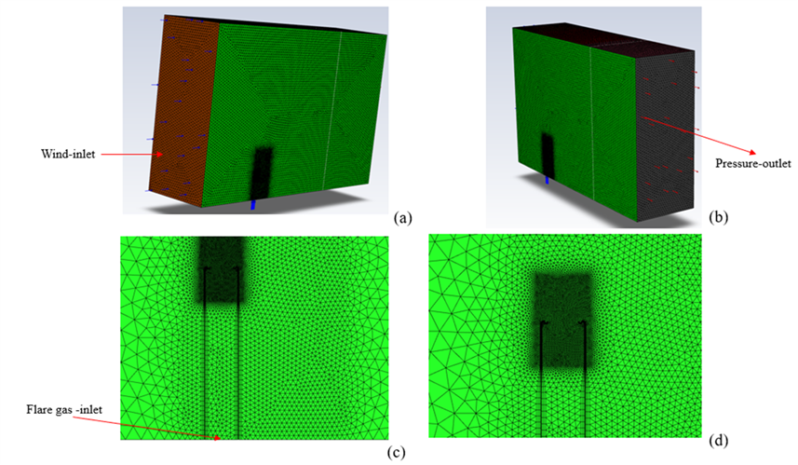

**Figure 1.** *Rectangular domain and meshing for Utility flare tip a) Wind inlet b) pressure outlet c) flare gas inlet d) finer meshing in the combustion zone.*

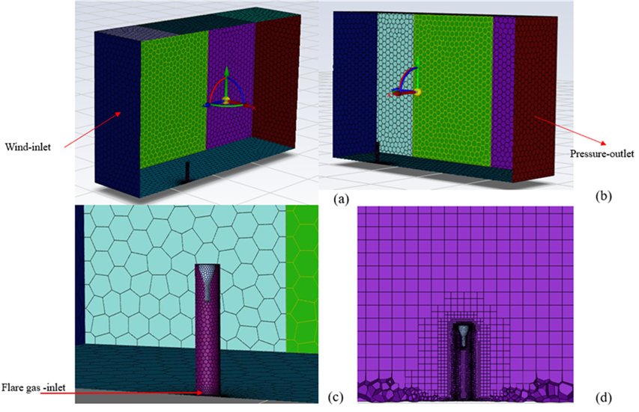

**Figure 2.** *Rectangular domain and meshing for Sonic flare tip: a) Wind inlet b) pressure outlet c) flare gas inlet d) finer meshing in the combustion zone.*

*2.3. Validation experimental design*

The net heating value of vent gas (NHV) is critical to flare ignition and sustained burning. This is normally expressed for unassisted flares in BTU/scf with alternate equations available for air and steam assisted flares to account for the role of these additional gases. Turbulent mixing of the vented gas and ambient air dictates whether the mixture attains flammable conditions to maintain a high CE/DRE. Mixing characteristics are, in turn, a function of the gas flow rate, the speed at which it exits the flare tip and, ambient air conditions and crosswinds. MFR (momentum flux ratio) is a parameter used in flare combustion studies to quantify the momentum transfer from the gas to the surrounding atmosphere that includes consideration of crosswinds. A high MFR indicates a strong momentum transfer and better mixing of the combustion products with the surrounding air, which can improve combustion efficiency and reduce emissions. As the MFR increases, the behavior of the flare flame can be classified into three distinct regimes: wake-dominated, buoyancy-dominated, and inertia-dominated [11]. MFR is defined as:

$MFR=\frac{ρ_{vg* {V_{vg}}^{2}}}{ρ_{air}* {V_{wind}}^{2}}$ (4)

Where MFR is Calculated momentum flux ratio, unitless. $ρ_{vg}$ is Density of flare waste gas, lb/scf. $V_{vg}$ is flare vent gas velocity, ft/s. $ρ_{air}$ is density of air, lb/scf. $V_{wind}$ is wind velocity, ft/s.

Validation relative to empirical data was conducted by simulating conditions tested by Evans et al. Seven single pipe utility flare tip cases with NHV values ranging from 200 BTU/scf to 930 BTU/scf and jet velocities ranging from 0.2 m/ s to 5 m/s were investigated as shown in Table 1. Five Sonic flare tip cases with NHV values ranging from 170 BTU/scf to 600 BTU/scf and jet velocities ranging from 0.5 m/ s to 2 m/s were investigated as shown in Table 2. Gas composition replicates the same gases used by Evans et al. [7] in which a range of NHV values were formulated by mixing TNG with nitrogen. These table shows for each case the gas composition, net heating value of vent gas (NHV), jet velocity (Vjet), crosswind velocity (U), and momentum flux ratio (MFR).

**Table 1.** Utility flare tip Experiment test conditions

|  |  |  |  |  |  |  |  |
| --- | --- | --- | --- | --- | --- | --- | --- |
| Test No. | Flare Type | TNG Flowrate (SCFH) | N2 Flowrate SCFH) | NHV (BTU/SCF) | Vjet (m/s) | U (m/s) | MFR |
| 1 | Utility | 8666 | 30313 | 213 | 4.93 | 3.57 | 1.7240 |
| 2 | Utility | 341 | 1216 | 214 | 0.19 | 4.92 | 0.0014 |
| 3 | Utility | 1272 | 3476 | 253 | 0.60 | 1.79 | 0.0975 |
| 4 | Utility | 10542 | 28402 | 260 | 4.92 | 5.36 | 0.7498 |
| 5 | Utility | 12661 | 25628 | 305 | 4.84 | 3.13 | 2.1606 |
| 6 | Utility | 3080 | 1648 | 559 | 0.59 | 4.02 | 0.0164 |
| 7 | Utility | 39267 | 0 | 929 | 4.96 | 2.68 | 2.0531 |

**Table 2.** Sonic flare tip Experiment test conditions

|  |  |  |  |  |  |  |  |
| --- | --- | --- | --- | --- | --- | --- | --- |
| Test No. | Flare Type | TNG Flowrate (SCFH) | N2 Flowrate SCFH) | NHV (BTU/SCF) | Vjet (m/s) | U (m/s) | MFR |
| 1 | Sonic | 366 | 1753 | 170 | 1.19 | 7.15 | 0.0255 |
| 2 | Sonic | 234 | 809 | 201 | 0.58 | 1.34 | 0.177 |
| 3 | Sonic | 570 | 1519 | 240 | 1.17 | 1.34 | 0.698 |
| 4 | Sonic | 1393 | 2861 | 290 | 2.39 | 4.47 | 0.244 |
| 5 | Sonic | 682 | 371 | 513 | 0.59 | 4.92 | 0.011 |

*2.4. Investigation of crosswind*

To assess the effect of high crosswind speed on CE and DRE, the MFR range considered was varied from 10-4 to 103 covering the different combustion regimes as defined by Seebold et al [11]. Four flare tip velocities (0.6 m/s, 1.2 m/s, 2.4 m/s, and 5 m/s) were designed to cover the range operating flow rates of gas in keeping with previous empirical studies. The NHV varied from 100 to 920 BTU/scf.

**3. Results**

*3.1. Model validation against FlameD*

Turbulent Non-premixed Flame (TNF) Flame D experimental data [12] was used to fine-tune the modelling approach. Availability of extensive measurement data for the Sandia Flame D makes it an effective benchmark for gauging the CFD models. To replicate the Flame D conditions in the model accurately, the conditions at the model boundaries must be matched closely to that of the experimental setup. However, the velocity profile of the vertically driven co-flow is complex with a peak value of 0.9 m/s and dropping radially away from the flame. Therefore, a simplified plug flow profile with a constant value of 0.9 m/s was used in this study.

The axial temperature profile along the centerline of the simulated flame was compared with the experimental results shown in Figure 3. The model predicted the peak temperature value and the functional shape qualitatively well. However, slight differences existed on the flame shape and structure. The observed differences could be arising from the simplifying assumptions made to the model inflow boundary conditions and the simplified steady RANS approach used. Flame D report did not directly calculate CE, however, radial profiles of the key species such as CH4, CO2, CO are available downstream from the flame. These profiles are used to calculate the experimental CE to be 98.2% compared to the simulation predicted CE of 98%. Since the focus of this study is to predict the CE of large flares, this relatively simpler steady state approach is deemed to strike the right balance between the CE prediction accuracy and the computational cost.

*3.2. Model verification against physical test data.*

Figures 4 and 6 compare CE results between experiment and simulation techniques. In both cases, as NHV increases so does CE. Uncertainty analyses are summarized in next chapter 3.3. Figures 5 and 7 show the temperature contour plots for utility cases 3, 5 and 7 and sonic case 3, 4, and 5. Flame length and peak flame temperature are a strong function of the flare gas net heating value, the flow rate and wind speed. Crosswind shifts the fuel-air mixing zone to the downwind side which results in the observed flame downwash. Higher crosswind also creates higher shear in the flame region increasing the risk of local flame quenching. However, high crosswind does not always lead to low CE as the standing vortex developed on the lee-ward side of the flare tip can anchor and stabilize the flame [13].

**

**Figure 3.** *Temperature VS Axial Distance for Experimental Results and CFD Calculation.*

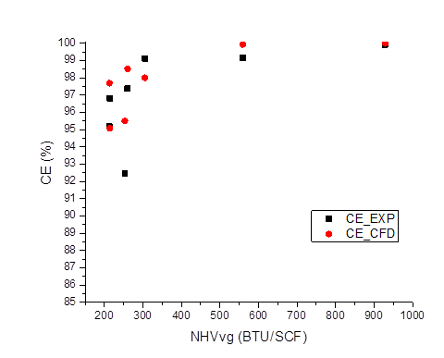

**Figure 4.** *Single Pipe Utility flare tip CE validation Results.*

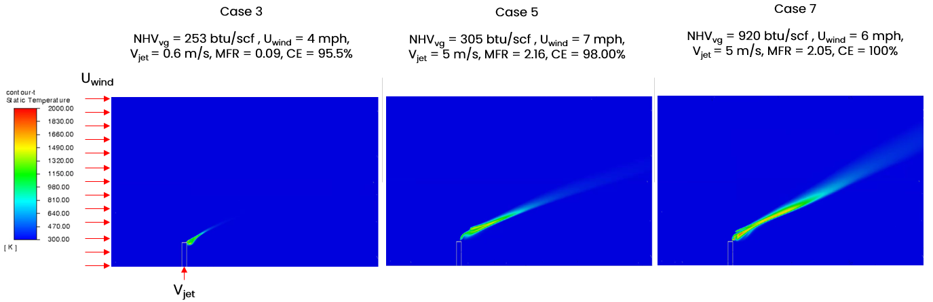

**Figure 5.** *Temperature contours (K) along flame central plane for Single Pipe Utility flare tip*



**Figure 6.** *Sonic flare tip CE validation Result.*

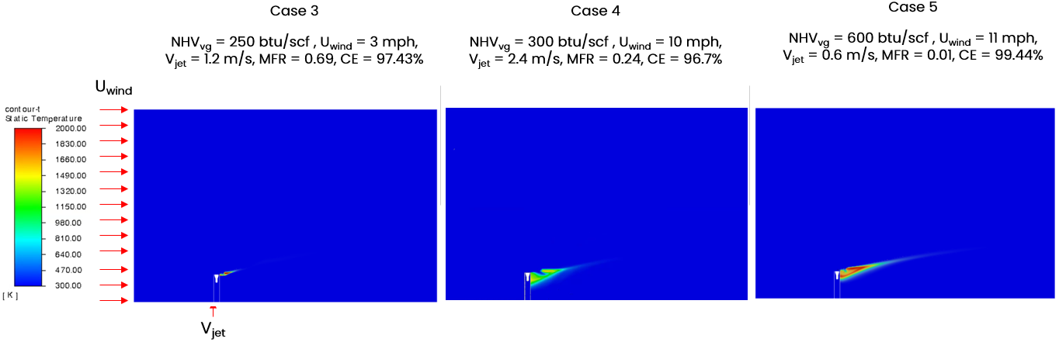

**Figure 7.** *Temperature contour (K) along flame central plane for Sonic flare tip*

*3.3. Uncertainty analysis of CFD Validation Results*

Uncertainty in the combustion simulations arise from several sources. Numerical uncertainties are due to the limitations of the numerical methods used to solve the transport equations. Modeling uncertainties are due to the simplifications and assumptions made in the mathematical models used to describe the fluid flow (e.g., turbulence model or inflow profiles). Geometric uncertainties are due to simplification made in the geometry of the flare tip system being simulated. For example, pilots are not explicitly modeled, flame stabilization tabs around the tip of the utility flare and the sonic tip internal connectors are simplified to manage the model complexity. All the above uncertainties contribute to the total model systemic error.

Uncertainty of the measurements was estimated in accordance with the Guide to Expression of Uncertainty in Measurement, often referred to as the GUM [14]. The empirical testing (JZ) results are reported with an estimate of uncertainty by the vendor using the error propagation method. The JZ CE/DRE measurement, uncertainties were mainly introduced by instrument errors, and testing variabilities, such as sample extraction variations. Peter et al., [7] gave a detailed discussion on the experimental system uncertainties (eCE-sys) and demonstrated that it increases as the NHV is decreases.

Model uncertainty (Dif) is calculated as a percentage of deviation between CEcfd and CEexp. Tables 3 and 4 are uncertainty results for the single-pipe utility flare tip and sonic flare tip. Dif decreases as NHV increases for both flare tips, which is consistent with eCE-sys. For the utility flare tip in Table 3, when NHV values are less than 250 BTU/SCF, the CFD predicts around 1.83% higher CE than the experimental results and 3% higher CE than experimental CE for the sonic flare tip in Table 4. When NHV values are greater than 250 BTU/SCF, the difference between the experimental and CFD model outputs for both the utility flare tip and sonic flare tip is smaller, with an average difference of 1% for the utility flare tip in Table 3 and 0.18% for the sonic flare tip in Table 4. eCE-sys rapidly increases when NHV is less than 300 BTU/SCF. This low NHV operating regime poses challenges to both CFD models and experimental measurements due to flame instability and local extinction. Uncertainty should be taken into consideration when analyzing flare performance.

**Table 3.** Uncertainty Results for Utility flare tip validation cases

|  |  |  |  |  |  |  |
| --- | --- | --- | --- | --- | --- | --- |
| Test No. | Flare Type | NHV (BTU/SCF) | CEexp | CEcfd | Dif(%) | eCE-sys |
| 1 | Utility | 213 | 95.19% | 97.69% | 2.63% | 1.78% |
| 2 | Utility | 214 | 96.81% | 95.08% | 1.78% | 1.49% |
| 3 | Utility | 253 | 92.47% | 95.50% | 3.27% | 2.12% |
| 4 | Utility | 260 | 97.38% | 98.52% | 1.17% | 1.22% |
| 5 | Utility | 305 | 99.12% | 98.00% | 1.13% | 0.58% |
| 6 | Utility | 559 | 99.16% | 99.93% | 0.77% | 0.27% |
| 7 | Utility | 929 | 99.92% | 100.00% | 0.08% | 0.03% |

**Table 4.** Uncertainty Results for Sonic flare tip validation cases

|  |  |  |  |  |  |  |
| --- | --- | --- | --- | --- | --- | --- |
| Test No. | Flare Type | NHV (BTU/SCF) | CEexp | CEcfd | Dif(%) | eCE-sys |
| 1 | Sonic | 157 | 89.30% | 90.00% | 0.78% | 5.31% |
| 2 | Sonic | 201 | 88.10% | 97.04% | 10.15% | 2.64% |
| 3 | Sonic | 240 | 97.48% | 97.43% | 0.05% | 1.11% |
| 4 | Sonic | 290 | 96.87% | 96.70% | 0.17% | 0.09% |
| 5 | Sonic | 513 | 99.64% | 99.44% | 0.20% | 0.11% |

**4. Discussion**

*4.1. MFR (Wind Effects) Study*

A steady state solver was chosen over unsteady solver to sweep through the flare operating conditional space more efficiently. Initial validation and verification exercise has indicated that the CE can be predicted with sufficient accuracy. Calculated temperature profiles are used to estimate the overall flame shape and structure. The results demonstrate reasonable trends indicating longer hot gas plume with higher NHV and gas flow rates, while higher crosswinds bend the flame towards downwind side. At high crosswinds tip wake region plays an important role and a good computational mesh resolution must be maintained. Solution-based dynamic adaptive mesh strategy was used to track the evolving flame trajectory and efficiently cluster the grid points into the regions of interest.

Figure 8 explores the relationship between CE and MFR. CE increase for cases with the same NHV but increasing MFR, which helps to quantitively understand the impact of MFR on flare performance. Sonic and Utility flare tips are designed differently and exhibit different combustion performance. Therefore, it is meaningful to compare the CE results of these two flare tips. It shows that the CE for Utility flare tips were generally higher than sonic tips. For the same NHV, UC CE is higher than SC CE when MFR is comparable. More scatter in the results for the sonic flare tip compared to single pipe utility flare tip can be attributed to the difference in their design and flow dynamics. The sonic tip has a constricted opening at the tip exit resulting in complex ring flow pattern and significantly higher flow speed and shear. Utility flare tip has a simpler design with a flame stabilizer at the exit, leading to a more stable flow and combustion behavior. Therefore, increased scatter in the sonic tip results indicate that the combustion in this type of design is more sensitive to variations in operating conditions and environmental factors. Same MFR achieved by higher gas jet speed and lower wind speed decreases CE less than that with lower jet speed and higher windspeed [13]. This observation suggests that MFR alone is not sufficient to fully understand the crosswind effects and further investigation is needed to establish a proper relationship between CE and MFR.



**Figure 8.** *CE vs MFR results when NHV is constant.*

*4.2. Comparison Study with Numerical Parametric model*

A numerical parametric model was developed for calculating flare combustion efficiency (CE) and destruction and removal efficiency (DRE) and verified against available physical test data. The parametric model considers key variables influencing flare performance including flare vent gas net heating value, flare design, flow rate, exist velocity, and inert gas composition and environmental factor of crosswind speed, with each effect characterized using a parametric model [8]. Unlike the compute intensive CFD models, parametric models have the advantage of running in real time making them ideal digital twins deployable on operating assets for flare performance monitoring in real time. Physical tests were conducted on three full-scale industrial flares including- non-assisted, single-arm pressure-assisted, and multi-arm pressure-assisted flare designs and CE/DRE are reported based on an extractive sampling method [7]. In this work, the parametric model is further tested against the validated CFD model applied to additional cases that are not covered under the physical testing program. These cases, referred to as UC and SC, were designed to explore extreme operating conditions that are generally hard to achieve and measure in a controlled test environment but can be encountered on an actual operating asset. This not only allowed us to expand on the available data in the operating space but also to explore the critical boundary regions more thoroughly. For example, the CFD model was used to simulate scenarios wind speeds more than 20 m/s, conditions which have previously been reported as the point at which wind begins to significantly affect DRE.

Figures 9 and 10 are CE comparison results of CFD simulation and numerical parametric model. Results indicate that when the gas NHV greater than 300 btu/scf the predictions from the CFD and parametric model aligned well. However, when the gas NHV is less than 300 btu/scf CFD model predicted a CE that is generally higher than the parametric model. CFD model results suggest that the effect of wind speed (and MFR) on the flare performance in the 100-300 btu/scf region is less significant than predicted by the parametric model. With these CFD results, the parametric model can be optimized for the specific NHV region. Combining physical test and simulation test data yielded valuable information to predict methane emissions over a larger range of flare operating conditions.

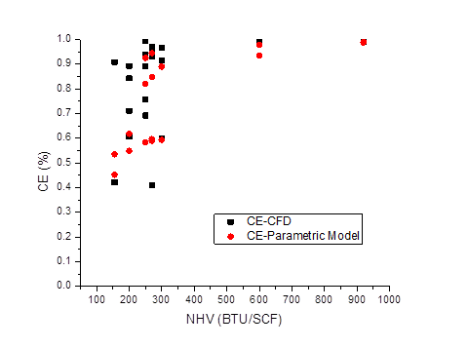

**Figure 9.** *CE vs NHVvg CFD and Parametric model comparison results for UC.*

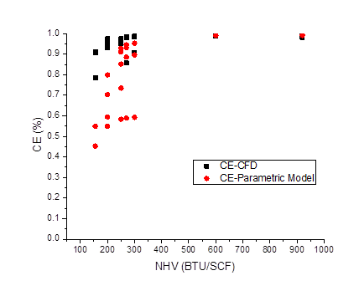

**Figure 10.** *CE vs NHVvg CFD and Parametric model comparison results for SC.*

**5. Conclusions**

Computational fluid dynamics methodology was used to simulate a 14” utility flare and an 8” pressure-assisted Sonic flare. First, the model was benchmarked against the physical tests by replicating a range of test conditions. CFD Model predicted CE matched reasonably well with the test measured CE. When gas NHV is above the critical threshold of 300 btu/scf simulation predicted CE is within 1%. At lower NHV there is greater departure between the CFD model predicted and the measured values. However, it is important to note that higher uncertainties were also reported in the measured values for gas NHV < 300 btu/scf.

A DoE (design of experiments) with a total of 48 cases was created covering a wide range of gas heating values (100-920 btu/scf), gas exit velocity (0.2-5 m/s) and wind speeds (0-50 m/s). CE dependence on the flare gas NHV and the momentum flux ratio (MFR) was explored. Results confirm that CE remain high (>95%) above and falls steeply below a critical flare gas NHV near 300 BTU/scf. Results also confirm that the critical NHV where the transition occurs is a function of MFR. Generally, a low MFR moved the critical NHV to higher values. Further investigation using simulations and field tests will help in better understanding the multivariate dependencies of CE (for instance on NHV, MFR, flare tip design).

While the CFD models are derived from fundamental physical principles and thus, considered to be of higher rigor, the simulations are time intensive and cannot be used in real time as digital twins. Numerical parametric models, on the other hand, are lightweight and can be used for real time flare monitoring. However, they must be tested against reliable flare data for proper benchmarking. Simulations performed in this work enabled to further verify the numerical parametric model published earlier in more operating scenarios, including some extreme scenarios (high crosswinds, low NHV). The comparison demonstrated that the simulations predicted similar CE to that of the parametric model at NHV > 300 btu/scf while simulations showed generally higher CE at NHV < 300 btu/scf. This work demonstrates the feasibility of detailed physics-based models not only in supporting the design and operation of flares but also to complement physical testing programs by simulating flare conditions that are hard to manage in controlled test environments.

**References**

1. https://flaringmethanetoolkit.com/
2. Plant, Genevieve, Eric A. Kort, Adam R. Brandt, Yuanlei Chen, Graham Fordice, Alan M. Gorchov Negron, Stefan Schwietzke, Mackenzie Smith, and Daniel Zavala-Araiza. "Inefficient and unlit natural gas flares both emit large quantities of methane." Science 377, no. 6614 (2022): 1566-1571. https://doi.org/10.1126/science.abq0385
3. Shaw, Jacob T., Amy Foulds, Shona Wilde, Patrick Barker, Freya A. Squires, James Lee, Ruth Purvis et al. "Flaring efficiencies and NO x emission ratios measured for offshore oil and gas facilities in the North Sea." Atmospheric Chemistry and Physics 23, no. 2 (2023): 1491-1509.2.
4. Innocenti, Fabrizio, Rod Robinson, Tom Gardiner, Neil Howes, and Nigel Yarrow. "Comparative assessment of methane emissions from onshore LNG facilities measured using differential absorption lidar." Environmental Science & Technology 57, no. 8 (2023): 3301-3310
5. Allen, David T., and Vincent M. Torres. "TCEQ 2010 flare study final report." The University of Texas at (2011).
6. McDaniel, Marc, and Bruce A. Tichenor. "Flare efficiency study." (1983).

https://gaftp.epa.gov/ap42/ch13/s05/reference/ref_01c13s05_jan1995.pdf

1. Evans, Peter, David Newman, Raj Venuturumilli, Johan Liekens, Jon Lowe, Chong Tao, Jon Chow, Anan Wang, Lei Sui, and Gerard Bottino. "Full-Size Experimental Measurement of Combustion and Destruction Efficiency in Upstream Flares and the Implications for Control of Methane Emissions from Oil and Gas Production." Atmosphere 15, no. 3 (2024): 333. https://doi.org/10.3390/atmos15030333
2. Tao, Chong, Jon Chow, Lei Sui, Anan Wang, Gerard Bottino, Peter Evans, David Newman, Raj Venuturumilli, Jon Lowe, and Johan Liekens. "Validation of a new method for continuous flare combustion efficiency monitoring." Atmosphere 15, no. 3 (2024): 356. https://doi.org/10.3390/atmos15030356
3. Fluent, A. N. S. Y. S. "Ansys fluent theory guide." Ansys Inc., USA 15317 (2011): 724-746.
4. Smith, Gregory P. "GRI-Mech 3.0." http://combustion.berkeley.edu/gri-mech/version30/text30.html
5. Seebold, James, P. Gogoloek, John Pohl, and Robert Schwartz. "Practical implications of prior research on today’s outstanding flare emissions questions and a research program to answer them." In AFRC-JFRC 2004 Joint International Combustion Symposium, Maui, HI. 2004.

https://collections.lib.utah.edu/ark:/87278/s6w71nxb

1. Peterson, C.W. “Sandia National Laboratories Analysis Code Data Base.” Office of Scientific and Technical Information (OSTI), November 1, 1994. <https://doi.org/10.2172/10196812>.
2. OAQPS, EPA. "Parameters for Properly Designed and Operated Flares." Flare Review Panel (2012)
3. “Evaluation of Measurement Data — Guide to the Expression of Uncertainty in Measurement,” 2008. https://doi.org/10.59161/jcgm100-2008e.